Student Activity
8 Detecting radiation with a Geiger-Müller tube

TASK
To investigate the penetrating ability of three common types of nuclear radiation and the ability of different materials to absorb the energy associated with nuclear radiation.

THEORY
Besides the obvious fact that none of our senses can detect individual decay events, the nuclear decay process seems to be random, yet, at the same time, predictable. It is impossible to say which nucleus will become unstable enough to decay next, but it is fairly easy to use a Geiger counter to count the number of nuclei which decay per second throughout a radioactive sample. If you recorded the nuclear decay of a radioactive sample with a Geiger-Müller tube and counter (or nuclear sensor) and plotted counts per time interval over a period of time, the results would look like a standard distribution curve.

Because, in many ways, nuclear radiation behaves as though the radiation were tiny ‘bullets’, it makes sense that different materials absorb the energy of nuclear radiation in different ways. The nature of the material through which nuclear radiation moves influences how much energy is absorbed.

EQUIPMENT
• Geiger-Müller tube or nuclear sensor
• counter or computer interface
• power supply
• base and support rod
• radioactive sources (alpha, beta, gamma)
• forceps or tongs
• right-angle clamp
• shielding material: lead, paper, plastic and aluminium in 5 cm squares

NOTES ON METHOD

Warning: The radioactive sources used in this experiment may be dangerous if not handled properly.
If the sources are handled as follows, there will be little or no cause for concern:
• Do not touch sources with a bare hand.

• Pick up sources with forceps or tongs.
• Do not point a source towards a human body.
• Maintain a distance of about half a metre from sources when possible.
• Wash hands thoroughly after performing an experiment.

In the first part of this activity, the background radiation is measured.
In the second part of the activity, the radiation from three different sources that are shielded with different thicknesses of three different materials is compared.
The measurements are made from a fixed distance over equal intervals of time.

Connect the Geiger-Müller tube to its power supply and counter according to the instructions supplied with the equipment.
Clamp it securely in a retort stand as shown on the following page, so that the distance from each source is controlled.

8 Detecting radiation with a Geiger-Müller tube
continued

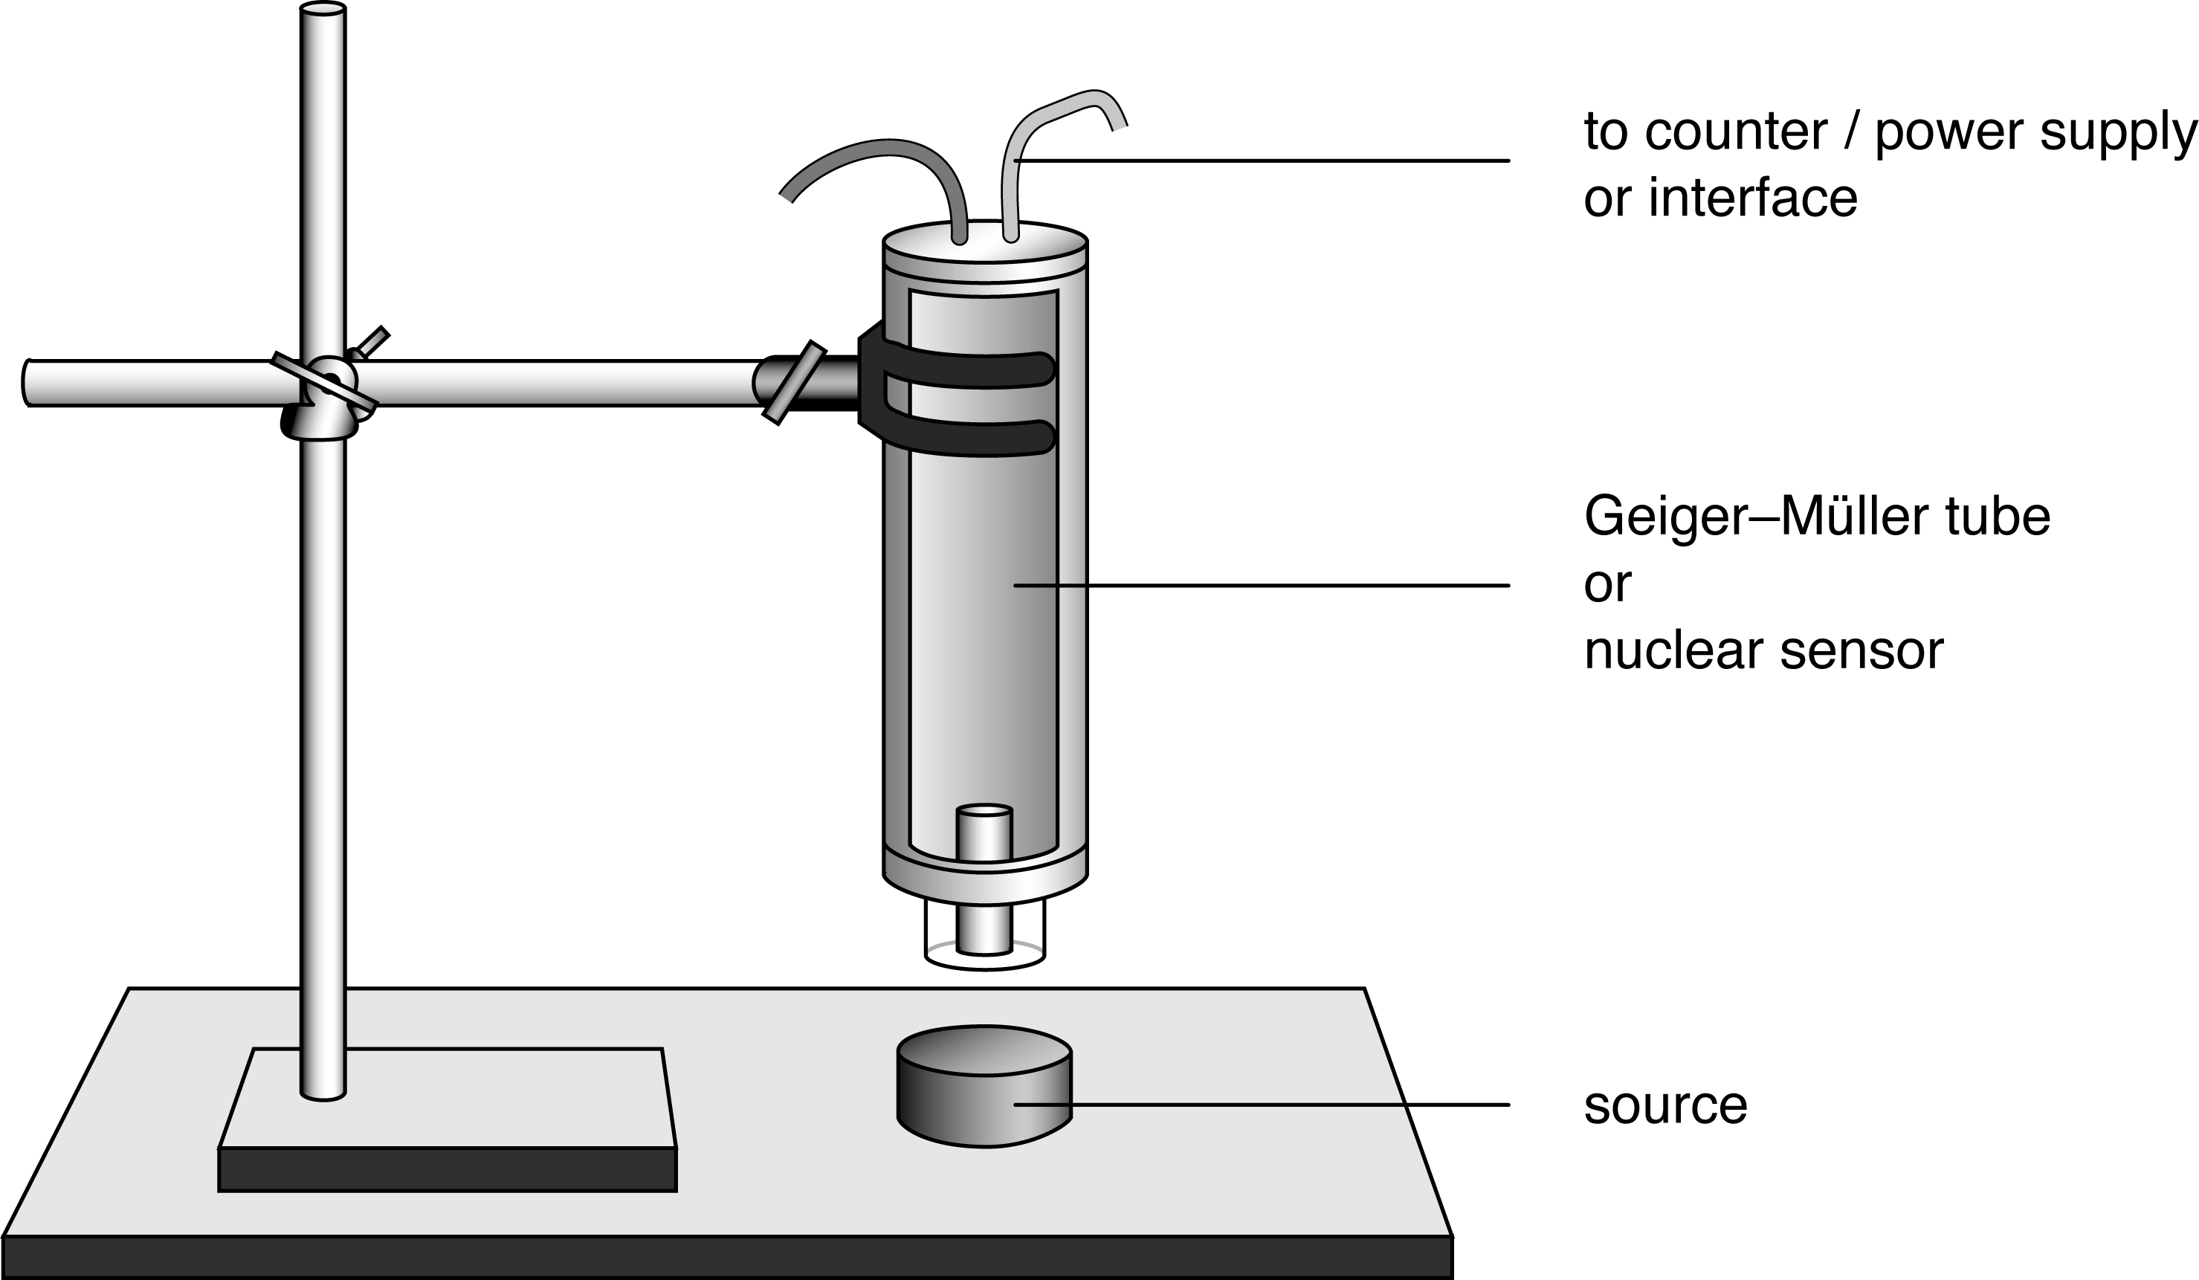

ICT
Settings for electronic measure options:
• table and/or graph display of counts per time period
• sample rate: 10 samples/second
• stop condition: 60 seconds
• calibration: generally not necessary with nuclear sensors.
Consult your equipment’s manual for instructions on configuring your equipment.

PART I: Background radiation
Move all radiation sources at least 3 metres from the Geiger-Müller tube.
Turn on the power supply and counter, and zero the counter.
Allow the counter to record for 60 seconds and record the number of counts.
Repeat 3–4 times during the course of the total activity to enable a reliable average to be found for the course of the activity. Make sure the samples are put away each time a background check is taken.

PART II: Radiation shielding
Use the same equipment set-up as in Part I.
The only difference in Part II is that you will be placing different radiation sources and different shielding materials directly below the Geiger-Müller tube.

1. Position the sealed alpha source under the Geiger-Müller tube at the bottom end of the nuclear sensor, without any shielding.
Turn the power supply and counter on, if they are not already.
Measure and record the number of counts over a 60-second period without any shielding over the alpha source.

2. Now measure the radiation counts from the alpha source when it is shielded by one layer of paper.
Repeat for two, three, four and five layers of paper. In each case, record the count for the 60 second sampling period.

3. Replace the sealed alpha source with a sealed beta source.
Repeat the steps, recording counts for the unshielded beta source and then for the source with one through to five layers of paper on top.
Record the number of radiation counts per 60 second period for each trial.

4. Replace the sealed beta source with a sealed gamma source. Repeat the data recording process again with no shielding, and then with one through to five sheets of paper.

5. Repeat steps 1–4 for each source using thin squares of plastic as the shielding material.
Record the number of radiation counts per 60 second period for each trial.

6. Repeat the entire process of data collection for each source using thin squares of lead metal as the shielding material. Record the number of radiation counts per 60 second period for each trial.
continued
8 Detecting radiation with a Geiger-Müller tube

7. If available, repeat the entire process of data collection for each source using thin squares of aluminium as the shielding material. Record the number of radiation counts per 60 second period for each trial.

DATA & ANALYSIS
Part I: Background radiation
Count 1:
Count 2:
Count 3:
Count 4:
Average count during activity:

Part I: Radiation shielding
Table: Radiation counts per minute (60 seconds)
Record your final data as the number of counts recorded for each trial less the average background count.

PAPER
Source | Number of layers
Source | 0 | 1 | 2 | 3 | 4 | 5
alpha
beta
gamma

PLASTIC
Source | Number of layers
Source | 0 | 1 | 2 | 3 | 4 | 5
alpha
beta
gamma

LEAD
Source | Number of layers
Source | 0 | 1 | 2 | 3 | 4 | 5
alpha
beta
gamma

ALUMINIUM
Source | Number of layers
Source | 0 | 1 | 2 | 3 | 4 | 5
alpha
beta
gamma

Construct a graph of number of layers of shielding versus counts for each type of radiation and material.
Graph all tests clearly on one set of axes, using different colours, so that clear comparisons can be made.

CONCLUSION
Summarise your results, commenting on the penetration of each source and the effect of shielding.

QUESTIONS
1. Which type of radiation is the most penetrating?
2. Which type of radiation is the least penetrating?
3. What generalisation can you make about the effect of the thickness of the shielding material on the count rate?
4. What generalisation can you make about the effect of the density of the shielding material on the count rate?
5. Why was background radiation measured? Do you expect the value to be constant?

